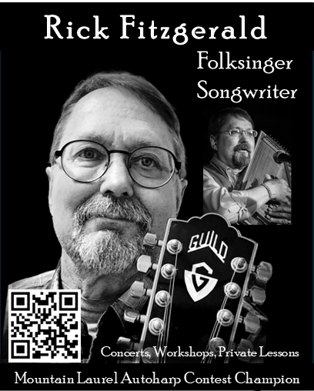

Short Bio
Rick is an accomplished guitarist, vocalist and songwriter, but is probably best known as an autoharp player. He uses a free-flowing, five-fingered picking style with his diatonic autoharps to deliver expressive melodies with interwoven harmonies.
He is the 2009 Mountain Laurel Autoharp Contest Champion and has performed & taught at autoharp festivals from coast to coast.
Rick has recorded four CDs featuring a mix of his own songs and those of his favorite artists, including John Denver, Gordon Lightfoot, Stan Rogers, and Bill Staines.

Contact: Phone: 414-916-7004
Email: Rick@RickFitzgerald.net / Rick@RootRiverMusic.com
Website: http://www.RootRiverMusic.com

DISCOGRAPHY: Earth Without Art 2019
Chasing Sunshine 2019
Crossing the Water 2012
Living Up to a Dream 2008

